# 1.Requirements document

Data requirements

1.Order

Every customer order is generalised as “order”. Data that should be maintained for the order entity includes an unique order number, order date, number of items ordered, quantity of each item ordered, price of each item, discount code -if applied , discount amount given(If any), tax charged, order type (pick up or delivery) , time the order was placed ,verification with customer , sub- total, amount due to be paid, payment method (cash or card payment), if paid by card then approval number and description about the order such as extra cheese etc. .

2.Phone order

Staff takes the phone order, so therefore the name of the staff is needed. This data is necessary to back track and find out who took the order

3.App order

This order type is placed using Apps and the data for this App order has a unique App order number that differentiates with that of the other order.

4.Walk in order

This order is placed with the customer physically walks into the shop and places the order. Only the customer name is recorded for this entity

5.Pick up order

The phone or App or walk-in order can be generalized as either pick up or delivery. Data needed for this type of delivery is order details.

6.Delivery order

Each delivery is recorded with the name of the driver who delivered the order, so that it is possible to back track and see who delivered the order.

7.Customer

This entity consists a unique phone number for every customer and customer name, customer address. Customer address is necessary for delivery orders.

8.Staff

There are three types of staffs such as staff who work in the shop, delivery drivers and manager who manages the staffs. Therefore, staff are generalized for the types of staff. The typical data for staff is needed such as a unique staff number, address, name (first, last), phone number, pay status (paid or not), date of join, pay rate (hourly/per delivery), tax fine number, licence number, bank account details to deposit pay for each shift such as bank code, name and payment record of the bank deposit.

9.Work in shop employee

The number of hours a staff works per shift is be recorded in this entity.

10.Delivery employee

Each driver is identified by a unique licence number. The number of deliveries delivered by the staff is stored in this entity.

11.Manager

Every manager is identified with a unique manager ID and manger salary details are recorded in this entity.

12.Shift

Each shift has start date with shift start time, end time and end date. There are number of shifts per day and a shift is worked by an employee.

13.Discount program

There are number of discount programs available. However only one discount is applied per order. Each discount category has a unique code, start and end date of the program, conditions of the discount that needs to be satisfied to be applied such as late delivery or loyal customer etc.

14.Menu Item

Each order contains number of menu items while each menu item is made of number of ingredients. The data that are essential for this entity is a unique number that identifies the menu item, name of the item, size (large, medium or small), and current price.

15.Ingedient

Each ingredient has a unique number, name, date of last stock taken, type of the ingredient such as veggie, cheese etc, recorded stock during stock take and the quantity that can be ordered, suggested stock level to be maintained and description of the ingredient such as “maintain above the recommended level” etc.

16. Supplier

Each supplier has a unique number and each supplier supplies many ingredients and many supplier orders are placed for a supplier.

17.Supplier order

Orders are placed to suppliers. Each order is identified by an order number with quantity of each ingredients.(Connolly & Beg, 2015.)

# Transaction requirements

Data entry

Enter the details of a new order (such as item code 5, quantity 2, no discount and to delivered with payment method by cash.)

Enter a new staff member who is classified as a shop assistant. (first, last name, phone number, description of the staff such as part time.)

Enter shift details (date with start and end time and date).

Enter supplier order (supplier number, ingredients numbers and quantity of each ingredients).

Data update/deletion

Update/delete the details of an order with description such as less tomato sauce.

Update/delete the details of a staff who is a manger.

Update/delete the details of a staff with new address.

Update/delete the details of a shift with different start times.

Update/delete the details of a supplier order with extra quantities added.

Data queries

1. List the details of the staff who joined the company on 15.01.2019.
2. Identify the staff who work part time and as a shop assistant.
3. List the names of delivery drivers, sorted by ascending order of their last name.
4. List the name of the in-shop worker who worked highest number of hours for the last week.
5. List the name of the delivery driver who delivered the highest number of deliveries for the last fort night.
6. Identify the name of the driver who delivered the order number A450.
7. Identify the shop assistant who took the phone order number B512 with start and end time of the order taken.
8. List the pickup times for the walk-in orders that is to be picked up before 10 pm tonight.
9. List the deliveries that need to be delivered before 8 pm tonight.
10. Display the total sales for the week.
11. Display the total amount of discount given for the month.
12. List the highest number of menu item sold for the day.
13. List the names of the ingredient with quantity at the stock take, ordered by level.
14. Display supplier number that has a supplier order number of OR271.

Business rules

1.Each phone or App order must go through verification process.

2. Only one discount program is applied to an order.

3. If the customer makes the payment by card then approval number should be recorded.

4.Each order should be either pick up or delivery, no dine -in facility.

# 2.Documented EER Model

Data Dictionary

|  |  |
| --- | --- |
| **Entity Name** | **Description** |
| Staff | Contains the details of all the staff members. |
| Order | Contains the details of all the orders placed. |
| Menu Item | Contains the details of all the menu items that is included in an order. |
| Ingredient | The list of ingredients used for menu items |
| Supplier | List of suppliers who supply ingredients. |
| Supplier order | The orders placed by the manger after the weekly stock take. |
| Phone order | The customer places orders via phone only. |
| App order | “Tasty n yummy” app is used to place the order |
| Walk in order | Customer walks into the store and places the order. |
| Pick up | The order is picked up from the store at the given time. |
| Delivery | The order is delivered by the delivery driver to the given address. |
| Shop assistant | Staff works in the shop and paid by hourly basis. |
| Delivery driver | Delivers the order to the given address at the given time. |
| Manager | Manages the store, paid by annual salary. |
| Discount program | List of Discounts programs. Only one discount per order. |
| Shift | List of shifts that are allocated with start date, including start, end time and end date. |
| Customer | List of customers details who placed the order. |

|  |  |  |  |  |  |
| --- | --- | --- | --- | --- | --- |
| **Entity name** | **Multiplicity** | **Relationship** | **Multiplicity** | **Entity name** | **Description** |
| Staff | 1..1 | Works | 1.. * | Shift | Each staff works 1 or many shifts |
| Staff | 1..1 | Takes | 1.. * | Order | Each staff takes 1 or many orders |
| Order | 1..* | Includes | 1..* | Menu item | Each order has 1 or many menu items included. |
| Supplier | 1..* | Supply | 1..* | Ingredient | Each supplier supplies 1 or many ingredients |
| Supplier | 1..* | Supplies | 1.. * | Supplier-Order | Each supplier supplies 1 or many orders. |
| Supplier Order | 1..1 | Includes | 1..* | Ingredients | Each supplier order includes 1 or many ingredients |
| Menu Item | 1.. * | Includes | 1.. * | Ingredients | Each menu item includes 1 or many ingredients. |
| Customer | 1..1 | Places | 1.. * | Order | Each customer places 1 or many orders. |
| Delivery Driver | 1..1 | Delivers | 1.. * | Delivery order | Each delivery driver delivers 1 or many orders. |
| Discount program | 0..1 | Applied in | 1.. * | Order | Each order is applied in 0 or 1 order. |

|  |  |  |
| --- | --- | --- |
| **Entity**  **Name** | **Attribute** | **Description** |
| Staff | Employee Number | A unique id given to every staff. |
| Staff | Address | Current address of each staff members. |
| Staff | First name | First name of staff is recorded. |
| Staff | last name | Last name of staff is recorded. |
| Staff | Phone number | Current phone number of staffs |
| Staff | Tax Number | Unique tax file number is entered for every staff |
| Staff | Pay rate | Pay rate applies to only shop assistants |
| Staff | Bank number | Each staff has a unique account number |
| Staff | Bank name | Name of the bank. |
| Staff | Pay record | Payment record for every shift, except manager. Managers are paid annually. |
| Staff | Pay status | Showing pay status, paid or not paid. |
| Staff | Description | Description for staff members like full time employee etc. |
| Order | Order Number | Unique order number is assigned to every order. |
| Order | Order Date | The date order was placed. |
| Order | Number of items | Number of items placed in each order. |
| Order | Item Quantity | Quantity of each item included in the order. |
| Order | Delivery time | Order delivery time either pick up or delivery order. |
| Order | Price of Item | Price of each item in the order |
| Order | Sub total | Total amount before discount and tax. |
| Order | Time of order | Time the order is placed |
| Order | Discount code | The code of discount program. One code is applied per order. |
| Order | Discount amount | The Percentage of discount given on the order. |
| Order | Tax | GST for the order. |
| Order | Amount due | Amount payable by the customer calculated after discount and tax applied. |
| Order | Payment method | Mode of payment. Paid by either cash or card. |
| Order | Status | Is the payment successful or declined |
| Order | Order type | Is the order type pick up or delivery |
| Order | Verification | Make sure the order is not hoax |
| Order | Approval number | If paid by card, then approval number is needed. |
| Order | Description | Comments such as enter via back of the property for delivery. |
| Ingredient | Ingredient number | Unique number given to each. |
| Ingredient | Date of stock take | When was the last stock take was done for the Ingredient. |
| Ingredient | Name | Name of the Ingredient such as Ham, pine apple etc. |
| Ingredient | Type | Type of Ingredient such as frozen, fresh etc. |
| Ingredient | Level at stock take | Quantity identified at stock take. |
| Ingredient | Suggested level | Recommended stock level to be maintained. |
| Ingredient | Desc | Description of the Ingredient such as monitor the stock level regularly. |
| Menu item | Item code | Unique code that identifies each menu item. |
| Menu item | Name | Name of the menu item such as Veggie supreme etc. |
| Menu item | Size | Such as medium size, large, small. |
| Menu item | Current price | The current price of the menu item, which may be the selling price. |
| Supplier | Supplier number | Unique supplier number for each supplier |
| Supplier order | Order number | Unique order number that identifies the supply. |
| Supplier order | Quantity | Quantity placed for each supplier order. |
| Shift | Start date | The date shift is allocated. |
| Shift | Start time | The time shift commences |
| Shift | end time | The time shift ends |
| Customer | Phone number | Unique number that identifies the customer |
| Customer | Customer name | Last and first name of the customer |
| Customer | Address | Address of the customer including post code |
| Work in shop | Hours worked | The number of worked per shift. |
| Manger | Manger Id | Each manger has unique Id |
| Manger | Salary | Annual salary paid |
| Delivery driver | Licence number | Each driver has unique drivers licence number |
| Delivery driver | Number of deliveries | Number of deliveries done by a driver per shift |
| Delivery order | Delivery number | Each delivery has the name of the delivered driver. |
| Phone order | Time | The time call was answered and terminated by the staff. |
| App order | App order number | Each app order has a unique number. |
| Walk in order | Customer name | Customer name is used to identify the order. |

EER Model-UML diagram

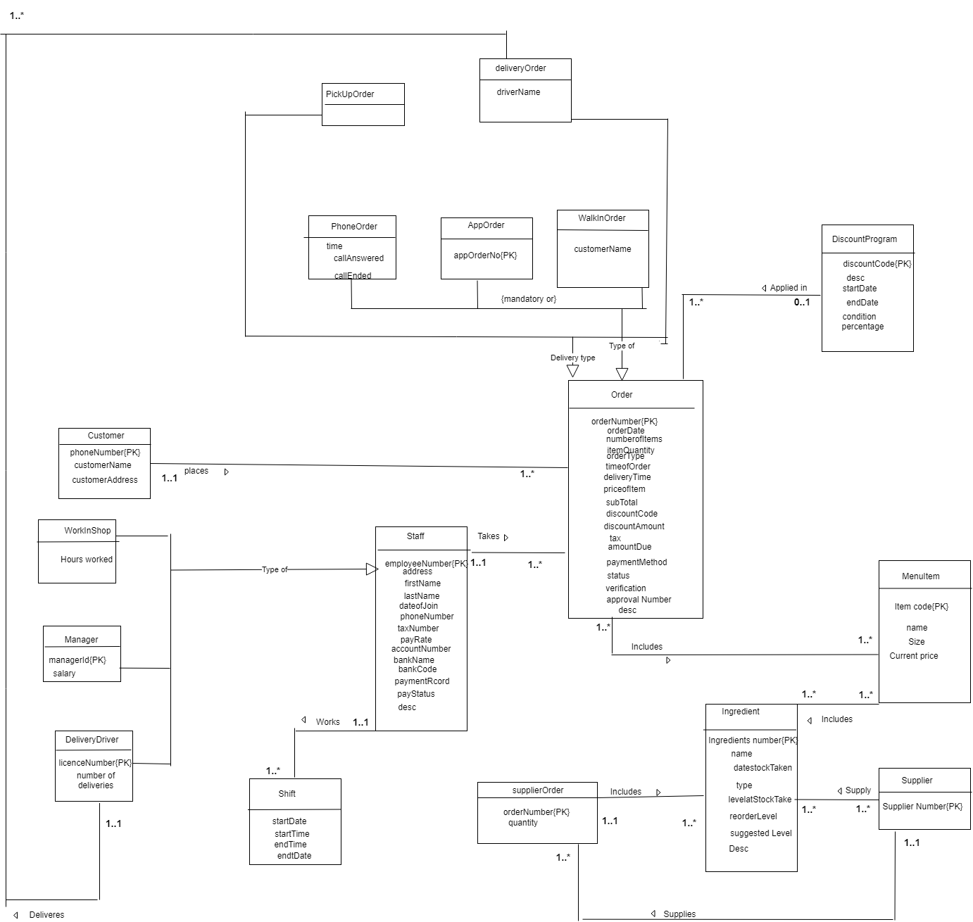

References

Connolly, T., & Beg, C. *Database systems*.